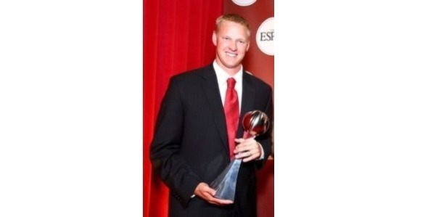

AARON THOMAS - INSPIRATIONAL SPEAKER

Calamus Wheatland is excited to announce an evening with Aaron Thomas, an inspirational speaker. The event will take place at the Calamus Wheatland Activity Center in Wheatland, 6:00pm, Wednesday, March 3, 2021. This is a free event and limited to the first 300 parents of Bennett & Calamus Wheatland students and/or residents of those communities.

Aaron will speak to CW high school students in the morning, and Bennett and CW staff in the afternoon. The 6:00pm session will be for the Bennett & CW parents and community members.
Please contact the high school office in Wheatland to reserve and pick-up your ticket(s) - call 563.374.1292.

